**Lab – 39: How to assign a public store app in Microsoft Intune?**

**Objective:** The objective of this lab is –

* To assign a public store app in Microsoft Intune.

In this lab, we are going to go through one of the quicker application deployment methods by assigning a public store app.

**Prerequisite:** EMS Enterprise Mobility + Security E5.

**Steps:**

1. Sign in to your Azure Portal, by using the link - **https://portal.azure.com/**. Enter your credentials and click Sign In.

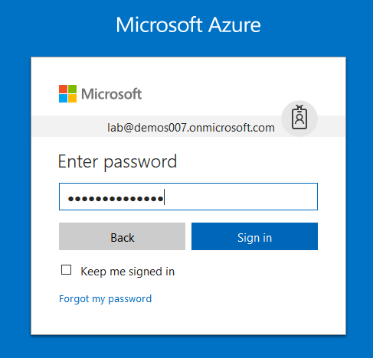

1. Microsoft Azure AD Dashboard will open.

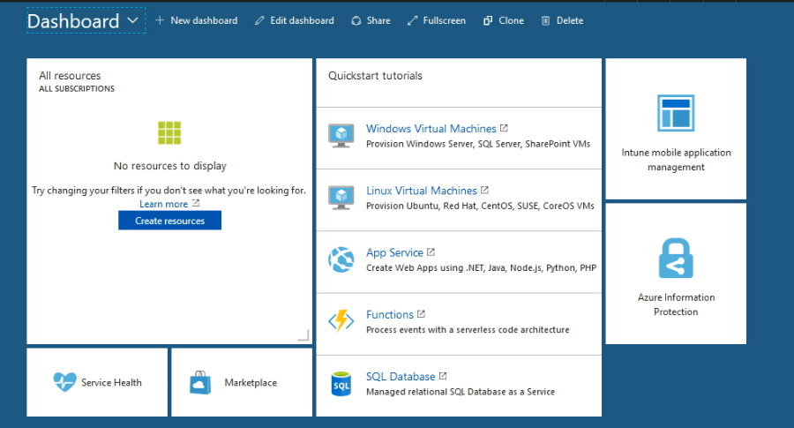

1. Open **Microsoft Intune** service from the left-hand side of the Azure portal.
2. Once you've opened the **Microsoft Intune** blade, select **Mobile Apps**.

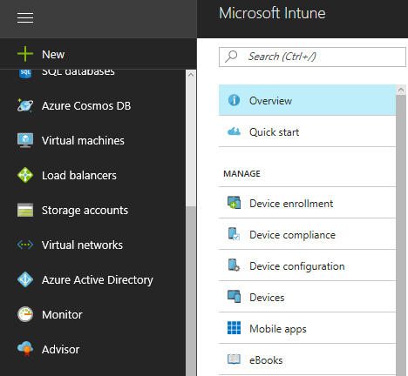

1. Then select **Apps**.

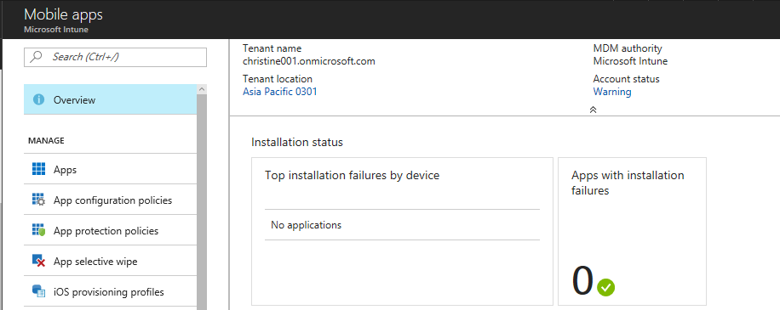

1. Select **+Add**.



1. Then **iOS store app** as the **App type**.

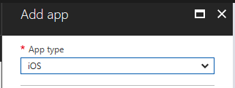

1. Then select **Search the App store** to select app.

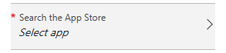

1. Search the App Store and select any app that you want to include. Click **Select**.

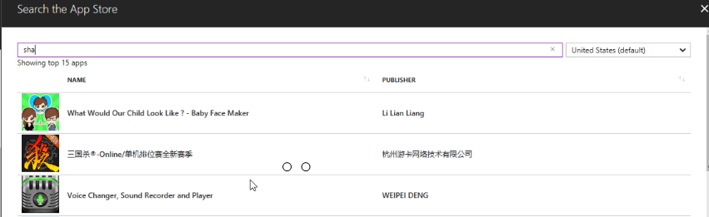

1. Now you can see the app is added in the Search the App Store.

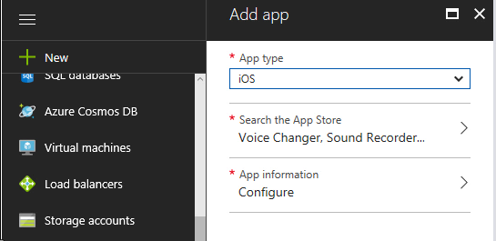

1. In the **Add app** blade, select **App information**, then make sure that all of the app information populated. You can add other optional details to help you organize this app, like **Name**, **Description**, **Publisher**, **Applicable device type**, **Category**, **Owner**, **Notes**, **Developer**, and a **Privacy URL** for your company’s privacy policy. Make sure that you’ve selected **Yes** for **Display this as a featured app in the Company Portal**, then select **OK**.
2. Select **Add** to add the app.
3. Now you can see the notification for application creation. And, the application is added in the list.

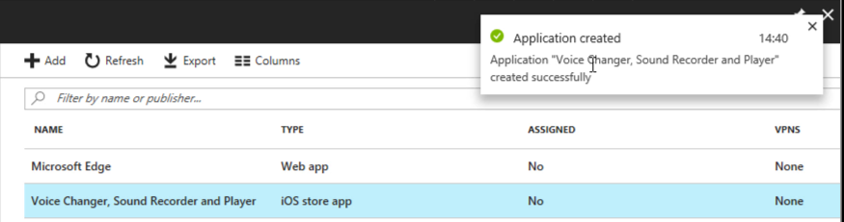

1. This will take you to that app’s **Overview**. Choose **Assignments**, then click **+ Select groups** to assign it to your test group.

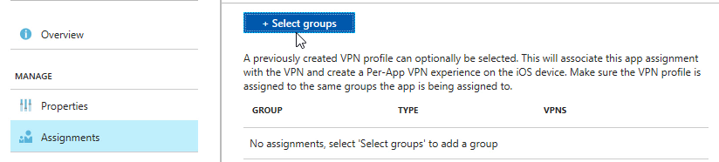

1. Select Test Group, then click **Select**.

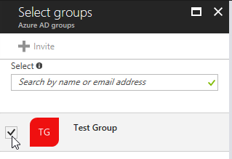

1. Now you can see, a test group is added.

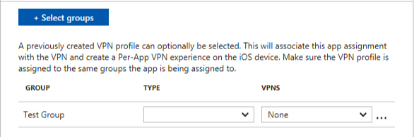

1. Make the app **Available** for download by selecting Type **Available**.

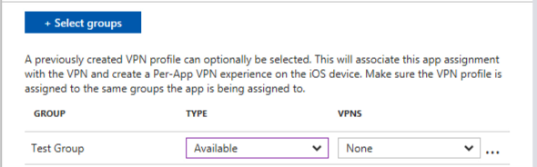

1. Then click **Save**.

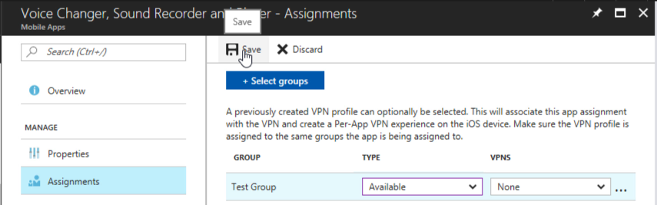

1. So, in this way you can assign a public store app in Microsoft Intune.